T-500S
Drilling and Tapping Machining Center
Technical Agreement
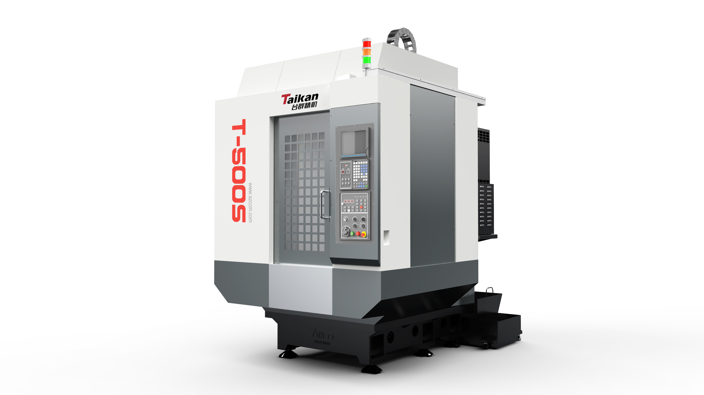
(This figure is for reference only)
- Technical description.
- Equipment technical description
T-500S Drilling and Tapping Machining Center adopts precision ball screw for the X, Y and Z axes, and precision linear guide rails for the X, Y and Z axes. Three axes are equipped with absolute servo motor. Spindle adopt a direct-coupling transmission structure, and standard maximum speed reaches 24000rmp. The cast iron are manufactured using meehanite casting process and undergo complete heat treatment to eliminate internal stress. Machine tool integrates drilling, tapping and milling processes, featuring high stability and high reliability. It widely used in the common industry, automotive parts, small mold processing, medical equipment, and other industries for the processing of small plate parts, disc-shaped parts, and shell components.
- Based on accumulated analytical technical data, with a six-point support of base, which improves the rigidity of machinery and ensures good stability of the machining process.
- The spindle motor and spindle adopt direct-coupling drive to reduce errors in high-speed tapping. The characteristics of high output force can be greatly utilized in high-speed and efficient processing.
- High-speed spindle has a fast response rate and uses ceramic ball bearings, greatly extending the lifespan of the spindle.
- Z-axis optimization improves stiffness and significantly increases Z-axis acceleration, reducing travel time of the noncutting stroke.
- The machine tool has a large inclined chip removal angle, which allows for rapid chip removal and accelerates the flow of cutting fluid.
- High-speed servo tool change, PLC tool change optimization, shortening tool change time, fast and stable, reducing non-processing time.
- It feature high-speed rigid tapping
- By loading a high-speed PLC engine, the response speed is improved, the cycle is shortened, the optimization of processing detail parameters, enhance the smoothness of the feed, and improved the processing effect.
- The machine design is simple and saves space. The front-end recessed design makes it easier for the operator to access the worktable machine tool.
- It adopts Mitsubishi M80A system, with friendly human-machine interface, simple operation and high production performance.
- Working conditions
(1) Three-phase AC power supply: 380V±5%; 50Hz±1Hz, the main power cable, ground cable ≥6 mm²/10mm²;
(2) The ambient temperature: Keep the ambient temperature 17 ~ 25℃, if the precision of the machining parts is not high, it can be relaxed to 5 ~ 40℃. Storage or transport temperature -20 ~ 60℃. ;
(3) Room temperature change: the ambient temperature change within 24 hours is within ±2℃;
(4) Relative humidity: Less than 75% (no condensation);
(5）Altitude: Below 1000m;
(6) Vibration: Below 0.2G;
(7) Foundation requirements: Bearing capacity of 32KN/m² or above;
(8) Keep away from light sources, vibration sources and heat sources, and keep away from high-frequency generators, discharge motors, electric welding machines, etc., to avoid electrical interference that will cause the NC system of the machine tool to fail.

2. Equipment parameters and configuration
2.1 Basic parameters
Item |  |  | Unit | Parameter | Remark
Travel | X-axis |  | mm | 500
Travel | Y-axis |  | mm | 400
Travel | Z-axis |  | mm | 320
Travel | Distance between table top and spindle nose end |  | mm | 180-500
Travel | Distance between spindle center and column guide |  | mm | 445
Worktable | Table size |  | mm | 620*400
Worktable | Max. load |  | kg | 250
Worktable | T-slot (number of slots-slot width*spacing) |  | mm | 3-14*120
Spindle | Motor power (rated/short time) |  | kW | 3.7/5.5
Spindle | Motor torque (rated/short time) |  | N.m | 14.1/21
Spindle | Spindle motor speed |  | r/min | 20-24000
Spindle | Spindle diameter |  | mm | Ф100
Spindle | Spindle taper |  |  | BT30
Guide rail | X-axis |  |  | 25
Guide rail | Y-axis |  |  | 30
Guide rail | Z-axis |  |  | 35
Drive | Screw X/Y/Z axes |  | mm | X:28/12 Y:28/12  Z:32/12
Drive | Motor power X/Y/Z axes |  | kW | 1.5/1.5/2.2
Speed | Cutting feed rate range |  | mm/min | 1-15000
Speed | Rapid traverse speed (X/Y/Z) |  | m/min | 48/48/48
Accuracy | Positioning accuracy (X/Y/Z) |  | mm | 0.006 | GB/T18400.4  (total Travel)
Accuracy | Repeat positioning accuracy（X/Y/Z） |  | mm | 0.004 | GB/T18400.4  (total Travel)
Tool magazine | Tool storage capacity |  | T | 21
Tool magazine | Max. tool weight |  | kg | 3
Tool magazine | Max. tool length |  | mm | 300
Tool magazine | Max. tool diameter (full /adjacent empty) |  | mm | Ф60/Ф80
Other | CNC System |  |  | Mitsubishi M80VA
Other | Air supply | Required flow | L/min | ≥200(ANR)
Other | Air supply | Regular air pressure | MPa | 0.6∼0.8
Other | Power capacity |  | KVA | 15
Other | Coolant tank volume |  | L | 145
Other | Dimension (L*W*H) |  | mm | 1660*2480*2330 | Corresponds to X*Y*Z axis
Other | Weight (approx.) |  | Kg | 2800
#: The dimensions of the machine are subject to change without prior notice due to configuration.

2.2 Customer-choosing configuration
NO. | Item | Quantity | Remark
1
2
3

2.3 Equipment standard configuration
NO. | Item | Quantity | Remark
1 | Direct-connected spindle 24000rpm | 1
2 | Spindle motor 24000rpm
3 | 21T servo tool magazine | 1
4 | Centralized automatic lubrication system | 1
5 | Explosion-proof work light | 1
6 | Three color warning light | 1
7 | SD card | 1
8 | Fully sealed outer cover sheet metal  protection | 1
9 | Pneumatic circuit system | 1
10 | Standard technical documents | 1 | Electronic file
11 | Mitsubishi M80VA system | 1
12 | Domestic tool magazine motor/drive | 1
13 | Pneumatic clamp solenoid valve | 2
14 | Safety door lock | 1 | Optional front automatic door, safety door lock cancelled

- Brands of main parts of equipment
Main parts
No. | Part name | Brand | Remark
1 | Screw bearing | FAG/NSK | Germany/Japan
2 | Ball screw | PMI | Taiwan
3 | Spindle unit | Taikan(24000RPM)
4 | Tool magazine | Taikan
5 | Main pneumatic components | SMC/CKD
6 | Spindle servo motor | Mitsubishi (24000RPM) | Japan
7 | Three-axis drive servo motor | Mitsubishi | Japan
8 | CNC System | Mitsubishi M80VA | Japan
9 | Tool magazine drives servo motor | / | Domestic
10 | Lubrication device | BAOTN
Note: In case of supply shortage, products of other brands will be used instead, but the quality and grade are not lower than the listed configuration.

- Main Function List of the System (Some functions require specific host configurations to be implemented).
No. | Function | Description | Notes
1 | Maximum total control axis (servo axis + spindle + PLC axis) | 11
1 | Maximum control servo axes | 9
1 | Maximum control spindles | 4
2 | Simultaneous control axes | Max. 4 axes
3 | Display unit | 8.4" color LCD screen
4 | Program capacity | 2500KB (NC storage + NC storage 2)
5 | High-speed machining mode
6 | High-speed, high-precision control | Max 202 kBPM
7 | SSS control
8 | Tolerance control
9 | Minimum instruction unit to 0.0001 mm | System can set minimum instruction unit
10 | Imperial/metric conversion | Conversion of machine units
11 | Decimal input | Programming instruction data specification method
12 | Positioning
13 | Linear interpolation | Multi-axis or single-axis coordinated movement control function
14 | Circular interpolation | Circular machining function
15 | Spiral interpolation | Spiral machining function
16 | Polar coordinate interpolation
17 | Polar coordinates
18 | Automatic acceleration/deceleration control
19 | High-speed rigid tapping | Reduces rigid tapping time and errors
20 | Thread time constant switching
21 | Manual rapid feed
22 | JOG feed
23 | Incremental feed
24 | Handwheel feed
25 | Pause
26 | Background editing | Program editing while machining
27 | Calculation input
28 | Absolute, incremental setting | Programming instruction data specification method
29 | Screensaver
30 | Parameter guide
31 | Alarm guide
32 | Screenshot
33 | Status, clock, operation, edit, maintenance display
34 | Fault diagnosis | Check current machine fault status
35 | Multi-language display function | Multi-language switching display
36 | Input/output of machining programs, parameters, tool offsets, etc.
37 | Multiple connection interfaces, network port, USB transfer | USB (max 32GB)
38 | Digital, analog spindle available
39 | Spindle positioning | Stops spindle at a fixed point for tapping, tool change, etc.
40 | Spindle synchronization control
41 | Tool compensation | 400 groups
42 | Coordinate system | Basic: G52-G59, extended 48 coordinates
43 | Coordinate rotation | Rotate orthogonal coordinates for easier programming
44 | Plane selection | Use G17, G18, G19 commands to select the desired plane
45 | Reference point 1, 2, 3, 4 return
46 | Program segment skip selection | Skip program segments for more flexible operations
47 | Single program segment | Program can execute one segment at a time
48 | Dry run
49 | Mechanical lock
50 | Auxiliary function lock
51 | Graphic inspection
52 | Program restart | Restart after temporary interruption
53 | Manual insert, MDI insert, etc. | Insert during operation
54 | Rigid tapping retraction | Retraction during rigid tapping interruption
55 | Macro programming | Variable programming available
56 | Fixed cycle for hole processing | Fixed cycles for hole machining, e.g., deep-hole drilling
57 | Set external input mirror | Achieve symmetrical machining via setting or external trigger
58 | Arbitrary angle chamfering/corner R | Arbitrary angle chamfering/corner R
59 | Drawing size input | Input dimensions as per drawing, e.g., corner chamfer
60 | Programmable data input | Input of instruction program data such as parameters, tool offsets
61 | Automatic corner scaling | Control for automatic corner machining scaling
62 | Deceleration check | Check for deceleration stop position
63 | Programming guide
64 | Thread pitch, backlash compensation | Machine axis pitch and backlash compensation
65 | Arc radius error compensation
66 | Dynamic precision compensation | Smooth high-gain, dual feedback (closed-loop)
67 | Tool life management 1 | Tool life monitoring
68 | Tool life management 2 | Expanded tool life management
69 | Tool life management quantity | 200 tools
70 | Alarm stop for each machine group
71 | Data protection for each user level
72 | Stroke protection
73 | Interlock
74 | Operation history, data backup
75 | Custom API library
76 | MES interface library
77 | Power consumption calculation
78 | PLC position switch | PLC function, designed as needed
79 | PLC servo off
80 | PLC axis removal
81 | Wireless network (Wi-Fi)
82 | Cutting load control
83 | Operation history display function
84 | Expanded common variables III
85 | PLC support for ST language
86 | High-precision parameter adjustment function
87 | OMR-CC
88 | Drilling chip removal function
89 | Fixed cutting reduction mode for drilling
90 | Spline curve interpolation 2 (G61.4) | Supports parameter control
91 | Tilted surface machining multiple instructions (G68.4)
92 | Mechanical rotational center error measurement
93 | Mechanical rotational center error compensation
94 | QR code machining cycle
95 | Laser machining control | Requires laser interface module
Special Note: For more functions, please refer to the M80V series specification selection guide. Due to differences in machine configurations and designs, please refer to the agreement for ordering.

- Recommended oil and grease table (refer to this table according to the actual configuration of the equipment)
Lubricating Part |  | Quantity | Recommended Oil |  | Remarks
 |  | Quantity | Room temperature 10-40℃ | Room temperature 5-10℃ | Remarks
Guide rail screw | Oil lubrication | 2-4 L | Guide rail oil 68# | Guide rail oil 32# | 1. Please add oil when checking before daily work or when the warning appears.  2. Pay attention to changing oil at low temperature.  3. When using canned grease, the brand of canned grease must be consistent with the manufacturer of the oiler.
Guide rail screw | Oil lubrication | 0.7-0.8L | Lithium base grease 000#
Spindle screw cooler | Coolant cooler | 15-35L | BASF G48 antifreeze (no addition of any medium is allowed)） |  | 1. Please add antifreeze or oil when checking before daily work or when the warning appears.  2. Please change the oil at low temperature.
Spindle screw cooler | Oil Cooler | 20-40L | No. 10 Great Wall Spindle Oil | No. 5 Great Wall Spindle Oil
Motorized spindle | Oil and air lubrication | 2-4L | ENEOS SUPER MULPUS DX32 (Brand: VG32) |  | Please refuel during daily pre-work inspection or when a warning message appears.
Hydraulic station |  | 25-40L | Hydraulic oil HV32# | Hydraulic oil HV20# | 1. Check before work every day and replace with new oil every year.  2. Pay attention to replacing oil at low temperatures.
Booster cylinder |  | 0.1-0.2L | Hydraulic oil 32# | Hydraulic oil 20# | 1. Check before work every day, and add oil when the oil cup is only 1/3 full.  2. Pay attention to changing oil at low temperature
Cutting fluid |  | 100-400L | According to the workpiece material and processing conditions, select the appropriate cutting fluid (based on the actual tank capacity) |  | When the room temperature is below 5℃, please check whether the fuel tank is frozen before starting the machine.
Fourth axis |  | 0.8-1L | Gear Oil 150# | Gear Oil 100# | 1. Check before work every day and replace the oil every six months.  2. Pay attention to replace the oil at low temperatures.
Tool changer arm system |  | 7 L | Gear Oil 100# | 80W-90 Antifreeze diesel engine oil | 1. Check before work every day, and replace the oil every 2400 working hours or every six months.  2. Pay attention to replace the oil at low temperatures.
Requirements:
A. The coolant must be water-soluble;
B. The coolant must be chemically stable and have lubricating properties;
C. Ensure that the coolant is not toxic to the human body;
D. Ensure that the coolant does not harden or swell items made of rubber and resin;
E. Use low-foam coolant;
F. If cutting fluid (oil) is not used for a long time, the protective cover needs to be maintained regularly.

- Others
1. Matters not covered in this agreement shall be resolved through negotiation between the two parties.
2. This agreement is an attachment to the contract and will take effect simultaneously with the contract after being signed by Party A and Party B.
3. This agreement is made in duplicate, with Party A and Party B each holding one copy.

